**Spilit Partitioning Method to Partitioning a Table**

**Before Automation**

1. Create a table in which we need to perform partition

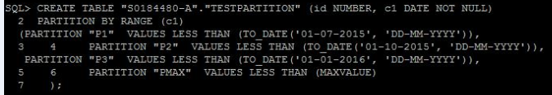

1. Insert some values in to the table
2. Get the PMAX value for the column by using the below query

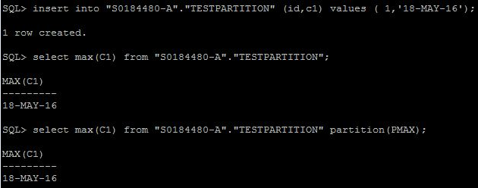

1. Create partition manually as mentioned below,

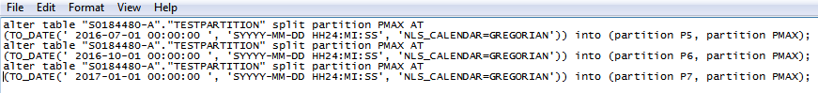

1. Verify the partitions

**After Automation**

1.Created a test table

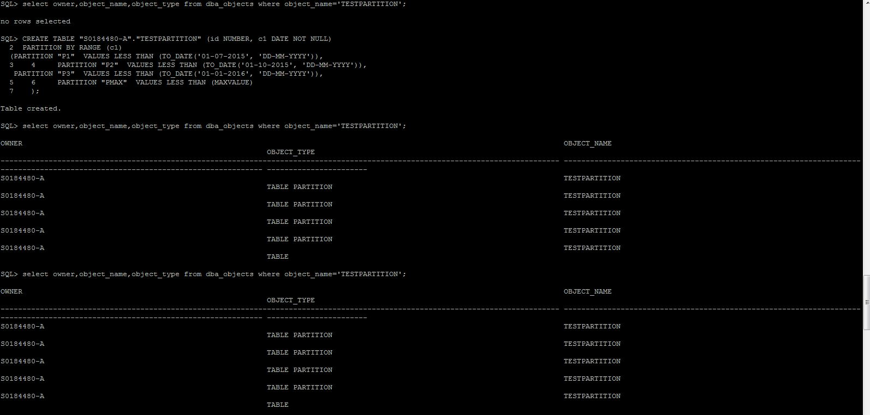

2.Insert values into the table.

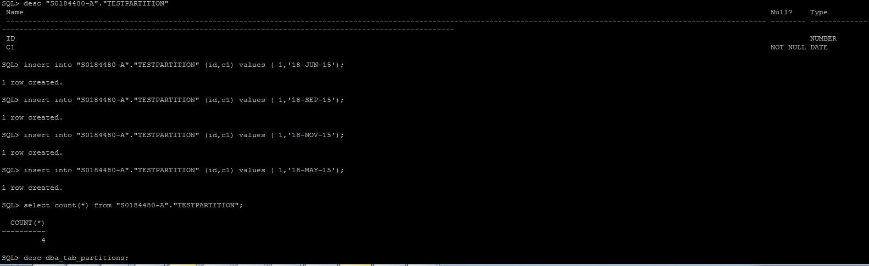

3.Selecting max partition date of the table.

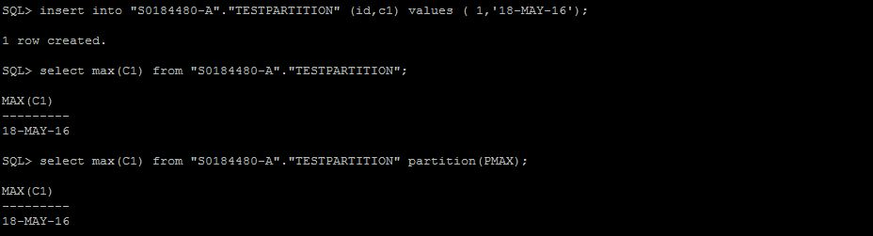

4. Automatically prints the max partition name and last date to be partitioned.

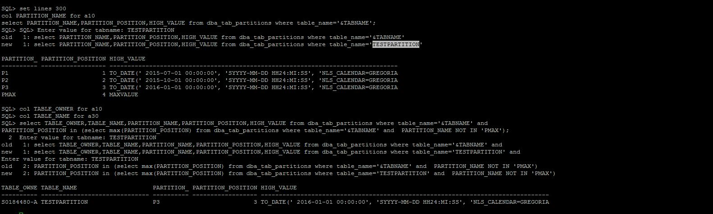

5. Automatically splits PMAX by taking tablename and owner as input.

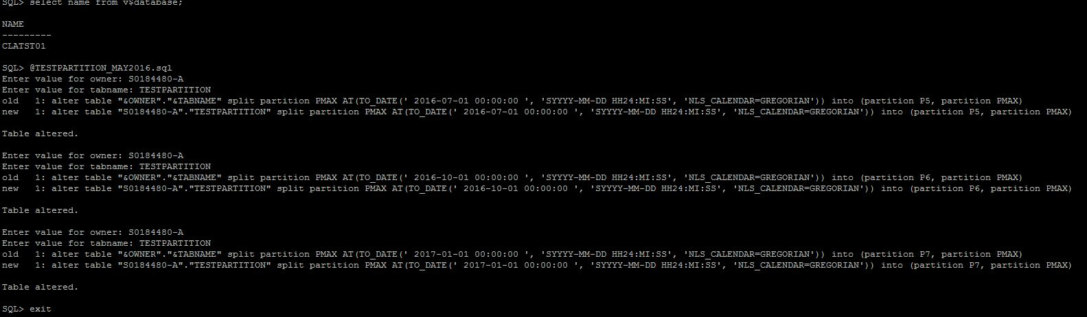

6. Partition P5 now holds the max partition date of the table.

